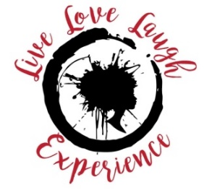
October 2 - 4, 2020
Hilton Head, SC

Website: Livelovelaughexperience.com email: livelovelaughexperience18@gmail.com

- 5 registration fees
- Ad in program (with website, logo and full-page ad)
- Your business brochures included in our sponsor’s booth
- Social Media Mentions
- 2 invitations for vendor spaces

- 3 registration fees
- Ad in program (with website, logo and full-page ad)
- Your business brochures included in our sponsor’s booth
- Social Media Mentions
- Invitations for vendor space

- 1 registration fee
- Ad in program
- Your business brochures included in our sponsor’s booth
- Social Media Mentions

- Vendor Table At Event
- Social Media Mentions
All Donations Are Tax Deductible
Make ckecks payable to Live Love Laugh Experience

